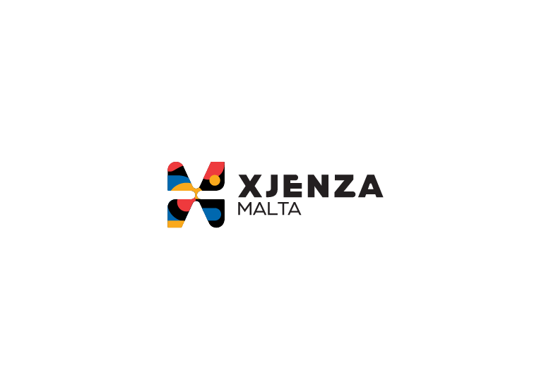

Terms and Conditions

Voucher Programme 2025 Call

In participating in the FUSION: Voucher Programme (hereinafter the “Programme”), the Beneficiary shall at all times abide and be bound by the following terms and conditions:

Article 1

For the purposes of the Programme the following definitions should apply (Refer to Rules of Participation for further definitions not listed hereunder):
  - Principal Investigator refers to the lead researcher on behalf of the local applicant/beneficiary of a transnational project consortium. May be the same as the Project Contact Point.
  - Research and Knowledge-dissemination Organisation means an entity (such as universities or research institutes, technology transfer agencies, innovation intermediaries, research-oriented physical or virtual collaborative entities), irrespective of its legal status (organised under public or private law) or way of financing, whose primary goal is to independently conduct fundamental research, industrial research or experimental development or to widely disseminate the results of such activities by way of teaching, publication or knowledge transfer. Where such entity also pursues economic activities, the financing, the costs and the revenues of those economic activities must be accounted for separately. Undertakings that can exert a decisive influence upon such an entity, in the quality of, for example, shareholders or members, may not enjoy preferential access to the results generated by it.
  - Single Undertaking means all enterprises having at least one of the following relationships with one another:
- One enterprise has a majority of the shareholders’ or members’ voting rights in another enterprise;
- One enterprise has the right to appoint or remove a majority of the members of the administrative, management or supervisory body of another enterprise;
- One enterprise has the right to exercise a dominant influence over another enterprise pursuant to a contract entered into with that enterprise or pursuant to a provision in its memorandum or articles of association;
- One enterprise, which is a shareholder in, or member of another enterprise, controls alone, pursuant to an agreement with other shareholders in or members of that enterprise, a majority of shareholders’ or members’ voting rights in that enterprise.
Enterprises having any of the relationships referred to in points (i) to (iv) through one or more other enterprises shall also be considered to be a single undertaking.

Eligibility for Participation

  - Applicants must be a Maltese registered legal entity.
  - Any Applicant which at the time of proposal submission is deemed to be non-compliant with respect to Grant Agreement obligations on any other active project funded by Xjenza Malta, may be deemed ineligible at application stage or may be refused funding under this programme. For the purposes of this paragraph non-compliance with respect to Grant Agreement obligations shall also be deemed to include failure to respect approved project timelines on other projects funded by the Agency and circumstances where the applicant is in recognised default of Grant Agreement obligations on any other active project funded by the Agency. Similarly, should applicants become non-compliant during the call process, they will not be awarded funding under this programme.
  - Funding under this scheme is made available on the basis that the Applicant has not benefited and will not benefit from any other grant or financial incentive of whatever nature, applied for and/ or utilised for the same costs and scope as that subject of the funding requested under this scheme.
  - Applicants under the Option A Rules for Participation regime must understand that, should they be found to be in breach of the applicable State aid rules, the Managing Authority will enforce the retrieval of disbursed funds with interest, in part or in full, as the case may necessitate.
  - Xjenza Malta also reserves the right to terminate any applications that have followed in part or in full the Option A Rules for Participation, should Xjenza Malta not be satisfied with the performance of the beneficiary.

Confidentiality of Submissions

  - All project application submissions shall be treated in the strictest confidence.
  - Without prejudice to the generality of the above it is only the name of the entity, the Project Contact Point, the title of proposal and the abstract which may in the course of the process be published.
  - The collection of data by Xjenza Malta through the application for aid under the Programme, submitted by the Applicant and the subsequent processing of said data by Xjenza Malta to evaluate the data subject’s request for aid under the Programme and the storage of said data shall at all times be in accordance with:
- The provisions of these National Rules for Participation; and
- Commission Regulation (EU) 2023/2831 of 13 December 2023 on the application of Articles 107 and 108 of the Treaty on the Functioning of the European Union to de minimis aid (the de minimis Regulation),where applicable.
- Data Protection Act (CAP 586 of the Laws of Malta) and Regulation (EU) 2016/679 of the European Parliament and of the Council of 27 April 2016 on the protection of natural persons with regard to the processing of personal data and on the free movement of such data and repealing Directive 95/46/EC (General Data Protection Regulation).
- The legitimate basis to process personal data submitted by the data subject by virtue of his/her written application for aid is Regulation 6 (1)(b) of the General Data Protection Regulation (“GDPR”), as ‘processing is necessary in order to take steps at the request of the data subject prior to entering into a contract’.
Further information may be found within the application form.

Double Funding

  - Funding under this Programme is made available on the basis that the applicant has not benefited and will not benefit from any other grant or financial incentive of whatever nature, applied for and/or utilised for the same scope as that subject of the funding requested under this Programme. Provided that, in the case where the application covers work that is part of a larger project, the Partner must submit a table as an appendix to the application form that shows a comprehensive list of the items of work and the source of funding for each item.
  - By signing the Grant Agreement, the Beneficiary is automatically accepting and authorising Xjenza Malta to exchange essential information related to the project with other funding agencies, both local and overseas, for any necessary checks. Any occurrence of double funding should be communicated in writing to the Unit Director prior to the signing of the Grant Agreement.

Allocation and Disbursement of Funding

  - Funding will be granted after Xjenza Malta is satisfied with the full completeness of work and submission of the necessary reports and, where applicable, the attendance of a meeting together with the Service Provider. Upon successful completion of the activity and confirmation of receipt of payment by the Service Provider, the beneficiary can obtain reimbursement for the Voucher from Xjenza Malta.
  - The total financial contribution over the lifetime of the activity shall not exceed the funding limit as established in the IPR Voucher, irrespective of actual expenditure.

Assistance with Applications

  - Prospective project applicants are encouraged to seek the advice of Xjenza Malta in the preparation of the voucher application. This should help identify any areas of concern prior to the submission of the application and lead to a better quality of submission. Advice shall only be given in respect to the Rules for Participation and not on technical grounds. Applicants are particularly encouraged to seek Xjenza Malta’s guidance through proposal-specific one-to-one sessions to ensure that the single-stage application documentation is complete and effective, as once submitted, cannot be edited.

Dissemination and Externalization

  - Dissemination articles and text material related to the project should include the words:
‘Project <Project Name> financed by Xjenza Malta, through the FUSION: R&I Voucher Programme.

Supervening Circumstances

  - The Principal Investigator is obliged to immediately advise the Unit Director, of any internal or extraneous significant event which might affect the validity or implementation of the project. This obligation applies to the entire period between the submission of the preliminary project application and the completion of the voucher.
  - Xjenza Malta shall acknowledge receipt within five (5) working days. The reply will either give such directives as it deems necessary for the furtherance on the project, or re-assess the project in its entirety accordingly.
  - Failure on the part of the Principal Investigator to respect this obligation may be deemed by Xjenza Malta to constitute material non-compliance on the part of the Beneficiary and Xjenza Malta may thereafter take such action as is necessary in terms of the Grant Agreement in consequence of such non-compliance.

Default

  - Where the implementation of a project becomes impossible or implementation is not completed, Xjenza Malta shall be entitled to take any action it deems necessary, including, but not limited to, the withdrawal of funding for the project and the collection of refunds of money already paid out. A similar course of action may be followed if a project is in default as a result of not meeting one or more of its obligations in terms of the Grant Agreement.
  - In the event of default on the part of the Beneficiary, Xjenza Malta may issue a written notice to the Beneficiary outlining the default, the corrective action to be taken and granting a rectification period of one month. Xjenza Malta may also issue a second written notice of default granting a rectification period in respect of the same default

The Grant Agreement

  - Following the successful evaluation of the application, the beneficiary shall be invited to sign a Grant Agreement establishing the terms and conditions governing the financing of the project.
  - Hard copies of the Grant Agreement must be signed within two (2) weeks from the date of receipt of the Grant Agreement by the Beneficiary. Where a legal representative is not available, a proxy should sign. Failure to comply with the stipulated timeframe may result in a withdrawal of the offer for funding.
  - When Xjenza Malta is satisfied that all the paperwork is in order, the Xjenza Malta executive responsible for the Voucher Programme will proceed to schedule an acceptance meeting between the beneficiary and the Service Provider. This meeting is chaired by a Xjenza Malta representative and brings together the applicant and the Xjenza Malta-approved service provider selected by the Beneficiary. During the acceptance meeting, the beneficiary will be asked to provide a confidential overview of their project to the Service Provider. The latter is bound by confidentiality through a non-disclosure agreement within their contract with Xjenza Malta. A copy of this NDA may be provided to the beneficiary upon request.
  - Should the beneficiary put forth any objections towards the assigned service providers, these will be taken in due consideration, and the beneficiary will be asked to select another service provider. The objections must be justified and are restricted to a maximum of two.

Interpretation of Rules

  - These T&C’s endeavours to establish comprehensive and clear rules governing participation in the Programme. However, should circumstances arise where the rules are inadequate, unclear, ambiguous, or conflicting, Xjenza Malta shall exercise its discretion in the interpretation of the rules or will extrapolate the rules as necessary through the setting up of an ad hoc committee.
  - The current T&C’s repeal any T&C’s previously issued and constitute exclusively the entire T&C’s issued by the Agency.
  - In the event of a conflict between the Grant Agreement and the Rules for Participation, the Grant Agreement shall take precedence.

